Wellbeing and Mental Health Policy



‘Cultivating the futures of our children’

 June 2024
At Hawthorn Primary School we recognise the important role mental health plays in learning and wellbeing. The World Health Organisation defines mental health and wellbeing as:
… a state of well-being in which every individual realises their own potential, can cope with the normal stresses of life, can work productively and fruitfully, and is able to make a contribution to their community.

We recognise that children’s mental health is a crucial factor in their overall wellbeing and can affect their learning and achievement. Within their school career all children will experience ups and downs and some may face significant life events. The Department for Education recognises that: ‘in order to help their children succeed; schools have a role to play in supporting them to be resilient and mentally healthy.’
Our Aims
At Hawthorn Primary School we aim to promote positive mental health and wellbeing for our whole school community (children, staff, parents and carers). We pursue this aim by using both universal, whole school approaches and specialised, targeted approaches aimed at vulnerable children. Pupils and staff will be taught skills to increase their awareness of mental health and emotional wellbeing. In addition to promoting positive mental health, we aim to recognise and respond to mental ill health. By developing and implementing practical, relevant and effective mental health policies and procedures we can promote a safe and stable environment for children affected both directly, and indirectly by mental ill health.
This policy describes the school’s approach to positive mental health and emotional wellbeing and it is intended as guidance for all staff including non-teaching staff and governors. It should be read in conjunction with our SEND policy, where a student may have an identified special educational need; the behaviour for learning policy, RSE policy, because behaviour, whether it is disruptive, withdrawn, anxious, depressed or otherwise, may be related to unmet mental health needs and the Safeguarding policy, in relation to prompt action and wider concerns of vulnerability.
The Policy aims to:
- Promote positive mental health in all students
- Increase understanding and awareness of common mental health issues
- Alert staff to early warning signs of mental ill health
- Provide support to staff working with young people with mental health issues
- Provide support to children suffering mental ill health and their peers and parents/carers
- Provide staff with the guidance so they feel equipped to deal with mental heath and wellbeing needs as they emerge

Responsibilities
All staff have a responsibility to promote the mental health and emotional wellbeing of pupils. Staff with a specific, relevant responsibility includes:
- Mrs Jacox - Headteacher, School Mental Health Lead and Designated Safeguarding Lead
- Mrs Martin – Inclusion Leader and Deputy Designated Safeguarding Lead
- Miss Blakeley – Deputy Headteacher and Deputy Designated Safeguarding Lead
- Mrs Tinto – Assistant Head and PSHE Lead
- Mrs Brown – Family Support Worker, Qualified Youth Mental Health First Aider and Deputy Designated Safeguarding Lead
- Mrs O’Key – Out of Hours Club Leader and Deputy Designated Safeguarding Lead

Whole School Culture
At Hawthorn Primary School, we recognise that our school environment and culture influence the wellbeing and mental health of our children. By providing a structured, inclusive, open, safe and calm community, we recognise the difference this can have on children’s emotional wellbeing. By promoting resilience, honesty and acceptance, we are able to go beyond the classroom and impact on multiple areas of a pupil’s life. We do this through:
- All staff recognising their role to play in providing a predictable and safe environment for children by following policies and procedures, along with the values of the school and the wider trust values. This includes ensuring the school remains a calm and safe place to learn and recognising the value of strong relationships with the children we teach.
- Emotional wellbeing through PSHE lessons, Zones of Regulation and taking part in Children’s Mental Health Week as well as providing
- Establishing effective working relationships with external partners and outreach services and keeping up-to-date with the local offer around mental health and wellbeing.

Definition of Mental Health
(Taken from the DfE Publication Mental Health and Behaviour)

Where children experience a range of emotional and behavioural problems that are outside the normal range for their age, they might be described as experiencing mental health problems or disorders.
Mental health professionals have classified these as:
- emotional disorders, for example phobias, anxiety states and depression;
- conduct disorders, for example stealing, defiance, fire-setting, aggression and anti-social behaviour;
- hyperkinetic disorders, for example disturbance of activity and attention;
- developmental disorders, for example delay in acquiring certain skills such as speech, social ability or bladder control, primarily affecting children with autism and those with pervasive developmental disorders;
- attachment disorders, for example children who are markedly distressed or socially impaired as a result of an extremely abnormal pattern of attachment to parents or major care givers;
- Trauma disorders, such as post-traumatic stress disorder, as a result of traumatic experiences or persistent periods of abuse and neglect;
- other mental health problems including eating disorders, habit disorders, somatic disorders; and psychotic disorders such as schizophrenia and manic-depressive disorder.

Diagnosis can only be made by a medical/health care professional. Schools are best placed to observe and identify children who may be at risk and signpost and support accordingly.

Identification
Pupil Identification Wellbeing measures include:
- staff observations
- any changes in a child’s behaviour, attention or presentation
- any communication from the pupils regarding their emotions, feelings or wellbeing.
- communication with parents

Any member of staff who is concerned about the mental health or wellbeing of a child, should record this on CPOMS in the first instance. We then implement an assessment of need to ensure that children get the support they need, either from within school or from an external specialist service. Our aim is to put in place interventions as early as possible to prevent problems escalating. If there is concern that the child is in danger of immediate harm, then the normal safeguarding procedures should be followed with an immediate referral to the safeguarding lead staff. If the child presents with a medical emergency then the normal procedures for medical procedures should be followed, including alerting the first aid staff and contacting the emergency services if necessary. Where a referral to CAMHS or the School Nurse is appropriate, this will be led and managed by the Family Support Worker. SEN support plans (One Page Profiles and/or IEPs) will identify any individual support needs for those pupils causing concern, or who receive a diagnosis pertaining to their mental health.

We offer an open-door policy whereby parents are able to speak to the Family Support Worker if they have concerns over the mental health or wellbeing of their child. When parental concerns are flagged, the Family Support Worker will record this onto CPOMS, gather the views of the child and decide on the next course of action.

Procedure for concern in relation to mental health and emotional wellbeing
If a pupil chooses to disclose any concerns about their own mental health, safety of wellbeing, or that of a friend, a member of staff’s response should always be calm, supportive and non-judgemental. Staff should listen, rather than advise and our first priority should be of the pupil’s emotional and physical safety. Disclosures should be recorded in writing and held on the pupil’s confidential file (CPOMS). This written record must include:
- Date
- The name of the member of staff to whom the disclosure was made
- Main points from the conversation

Support for Children – Waves of Support

Appendix 1
DFE – Factors thought to contribute to poor mental health
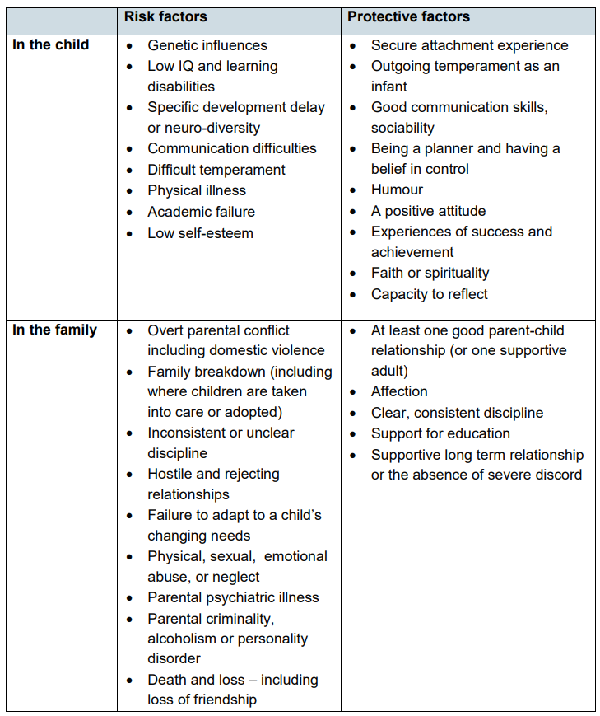
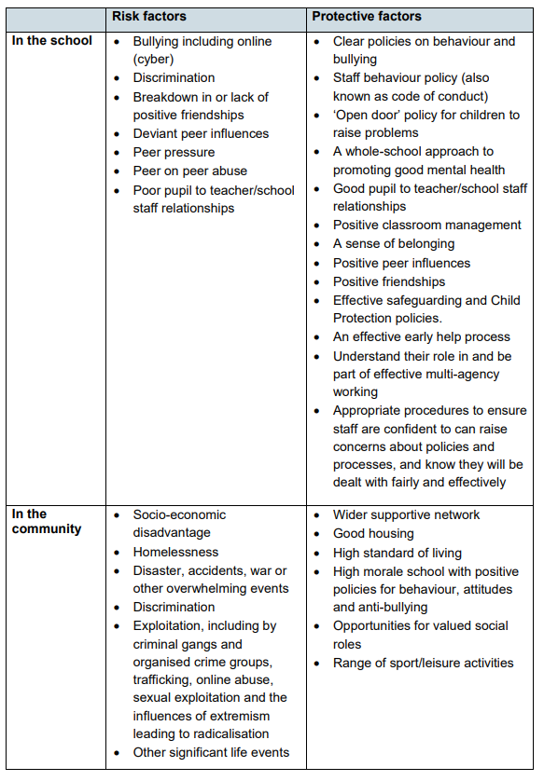
Appendix 2 – Support Organisations
Below is sign-posted information and guidance about the issues most commonly seen in school-aged children. The links will take you through to the most relevant page on the listed website. Some pages are aimed primarily at parents but they are listed here because the links are useful for school staff too.
CAMHS - WEBSITES | CAMHS Resources (camhs-resources.co.uk)
Links to lots of helpful websites covering a range of themes.
Support on all of these issues can be accessed via Young Minds (www.youngminds.org.uk), Mind (www.mind.org.uk) and for e-learning opportunities Minded (www.minded.org.uk).

Self-harm
Self-harm describes any behaviour where a young person causes harm to themselves in order to cope with thoughts, feelings or experiences they are not able to manage in any other way. It most frequently takes the form of cutting, burning or non-lethal overdoses in adolescents, while younger children and young people with special needs are more likely to pick or scratch at wounds, pull out their hair or bang or bruise themselves.
Online support www.selfharm.co.uk National Self-Harm Network: www.nshn.co.uk

Depression
Ups and downs are a normal part of life for us all, but for someone who is suffering from depression these ups and downs may be more extreme. Feelings of failure, hopelessness, numbness or sadness may invade their day-to-day life over an extended period of weeks or months, and have a significant impact on their behaviour and ability and motivation to engage in day-to-day activities.
Online support Depression Alliance: www.depressionalliance.org/information/what-depression

Anxiety, panic attacks and phobias
Anxiety can take many forms in children and young people, and it is something that each of us experiences at low levels as part of normal life. When thoughts of anxiety, fear or panic are repeatedly present over several weeks or months and/or they are beginning to impact on a young person’s ability to access or enjoy day-to-day life, intervention is needed.
Online support Anxiety UK: www.anxietyuk.org.uk

Obsessions and compulsions
Obsessions describe intrusive thoughts or feelings that enter our minds which are disturbing or upsetting; compulsions are the behaviours we carry out in order to manage those thoughts or feelings. For example, a young person may be constantly worried that their house will burn down if they don’t turn off all switches before leaving the house. They may respond to these thoughts by repeatedly checking switches, perhaps returning home several times to do so. Obsessive compulsive disorder (OCD) can take many forms - it is not jsu about cleaning and checking.
Online support OCD UK: www.ocduk.org/ocd

Suicidal feelings
Young people may experience complicated thoughts and feelings about wanting to end their own lives. Some youtube people never act on these feelings though they may openly discuss and explore them, while other young people die suddenly from suicide apparently out of the blue.
Online support Prevention of young suicide UK PAPYRUS: www.papyrus-uk.org

Eating problems
Food, weight and shape may be used as a way of coping with, communicating about difficult thoughts, feelings and behaviours that a young person experiences day to day. Some young people develop eating disorders such as anorexia ( where food intake is restricted), binge eating disorder and bulimia nervosa ( a cycle of bingeing and purging). Other young people, particularly those of primary or preschool age, may develop problematic behaviours around food including refusing to eat in certain situations or with certain people. This can be a way of communicating messages the child does not have the words to convey.
Online support Beat - the eating disorder charity: www.beateatingdisorders.org.uk/ Eating Difficulties in Younger Children and when to worry: www.youngminds.org.uk/parent/a-z-guide/eating-problems/
Support for Parents:

The Mental Health Telephone Line – Northants - The Mental Health Number | NHFT

NHS Talking Therapies Self-Referral - Northamptonshire NHS Talking Therapies | NHFT

Crisis Café – MIND – Local Venues - Crisis cafés | NHFT

Appendix 3

This Photo by Unknown Author is licensed under CC BY-NC
ELSA Support
Request for ELSA Support
Name of child
Class and year group
Date of birth

Relevant background information. What has led to this referral?
Add as much detail as possible.

Strategies/interventions attempted as part of wave 1 wellbeing support:

 |  | Skill | 1  Very  Poor | 2 | 3 | 4 | 5  Very Good
Emotional  Awareness |  | Ability to recognise how they feel
 |  | Ability to say how they feel and why
Social Skills |  | Ability to manage conversation successfully
 |  | Taking Turns
 |  | Sharing
 |  | Asking for help
 |  | Paying attention when spoken to
Friendship Skills |  | Ability to initiate friendships
 |  | Ability to maintain friendships
 |  | Understanding what friends do and do not do
Self-Esteem | Ability to identify strengths
Self-Esteem | Ability to accept praise
Self-Esteem | Ability to accept constructive criticism
Self-Esteem | Perseverance for tasks they find difficult
Self-Esteem | Ability to cope with new experiences/change
Anger management | Ability to recognise they feel anxious
Anger management | Knowledge and use of strategies to help calm down when angry
Anger management | Ability to seek adult help when angry/frustrated
Anxiety management | Ability to manage anxiety in response to everyday events
Anxiety management | Ability to respond to new challenges and change

Summary of conversation with parents:

Have they given consent? YES NO

Name of person completing this form:

To be completed by the ELSA:
Suggested focus/target for intervention:

Start date:

REVIEW
To be completed by the class teacher following the 6-week ELSA intervention to measure impact:
 |  | Skill | 1  Very  Poor | 2 | 3 | 4 | 5  Very Good
Emotional  Awareness |  | Ability to recognise how they feel
 |  | Ability to say how they feel and why
Social Skills |  | Ability to manage conversation successfully
 |  | Taking Turns
 |  | Sharing
 |  | Asking for help
 |  | Paying attention when spoken to
Friendship Skills |  | Ability to initiate friendships
 |  | Ability to maintain friendships
 |  | Understanding what friends do and do not do
Self-Esteem | Ability to identify strengths
Self-Esteem | Ability to accept praise
Self-Esteem | Ability to accept constructive criticism
Self-Esteem | Perseverance for tasks they find difficult
Self-Esteem | Ability to cope with new experiences/change
Anger management | Ability to recognise they feel anxious
Anger management | Knowledge and use of strategies to help calm down when angry
Anger management | Ability to seek adult help when angry/frustrated
Anxiety management | Ability to manage anxiety in response to everyday events
Anxiety management | Ability to respond to new challenges and change

